Mobile Applications Airen Surzyn

Calculator Design 2/4/15

The original Photoshop mock-up I did for the design of the calculator looked like this(left):

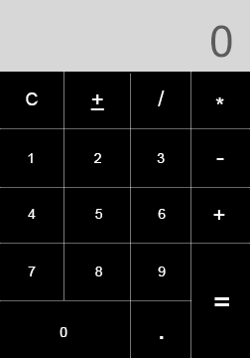

While I did have to adapt a few things during the construction of the actual app, I feel as though I was able to stay fairly true to my original intentions in the final result(below). Certain details such as the border lines to highlight the buttons or the proportioning of space in the EditText that I was able to achieve in Photoshop were slightly out of my reach when it came to Android Studio. However, in other areas, there were certain adaptations that I think improved the final result. For example, the smaller lettering provides a sleeker, more minimal look.

The black and white/gray design was inspired by a friend of mine who raves about minimalist and flat design trends, specifically with iOS products. For mobile devices flat design tries to 'free the content from the screen', and to make it appear as though it sits on top of the device rather than inside, going further to connect the user to his or her device.

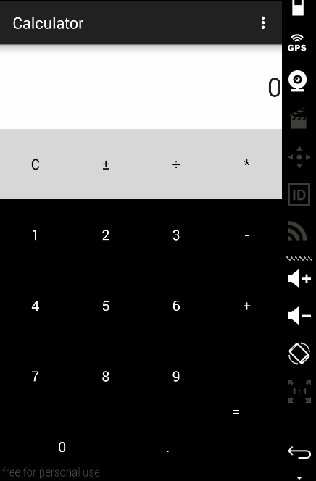

I took out the padding on the layouts that came stock with

the implementation in Studio so the EditText and the buttons could reach the edges of the screen. The physical device

itself provides the margins. There is no space between

any of the components so it all really looks like one piece. The smaller numbers and symbols were an aesthetic choice that I think made for a sleeker look, making use of the negative space in the button containers themselves. Black

and gray were fairly mundane choices because of the effect the white lettering has against this backdrop. Ideally, I

would have liked to have made the color of the buttons responsive to touch to make it feel even more interactive,

but I was unable to get this working. Many more weeks

to try that though.